CARAVEL ACADEMY
THIRD GRADE MUSIC

CLASS CONTENT:
Welcome to Third Grade Music! This year student’s will be reviewing past concepts and expanding their musical knowledge through continued progression using our Quaver Music Curriculum. Students will begin applying musical concepts learned in previous years through singing, playing the recorder and other classroom instruments. (A letter regarding the quaver program will be sent home soon so you can learn how to continue the musical magic at home!)
To see our weekly music curriculum, please feel free to view it at:
https://www.quavermusic.com/InfoCenter/FamilyOfPrograms/CurriculumMap_pdfs/3_CurrMap.pdf

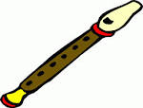
Recorder Program
- All students are issued a folder & recorder. If it is lost or broken, a new item must be purchased. Students MUST save them to also use in fourth grade.
- Students will also be able to access the recorder curriculum (b online as a part of our Quaver Curriculum.
- The majority of each student’s grade comes from bringing their recorder supplies to class each week.
- Students will play a recorder selection at the spring Fine Arts Festivals.
- More detailed information will be sent home before the recorders are passed out after winter break.

GRADING POLICY:
Students are given a final marking period grade of X, P or N. Grades are made up of 75% class participation and 25% assessments. Students are given weekly class participation grades using a 4-point rubric. Students are expected to:

*Cooperate with others to accomplish lesson goals
*Respectful to people and school property (instruments, games, etc)
*Follow class rules
*Listen to and follow directions and ask for help when needed
*Be focused and engaged in the class activity
*Ba a consistent, independent and a self-motivated learner.

Students are also given class projects and class assessments to evaluate their comprehension of the subject matter. Projects and assessments not completed in the allotted time frame may need to be completed and returned outside of class. Each project is graded using a 4-point rubric. Although the class assessments are important to me as an educator, ultimately class participation is the most important. All I ask is that a child tries to do their best.

Fine Arts Festivals (Our BIG Concerts!):
Each December and May the students perform in our Fine Arts Festival. These Festivals are very important because they are much like a final project determining a level of understanding and comprehension of musical and performance standards. These performances provide families an opportunity to enjoy the children showcasing their enthusiasm, creativity and love of music. And let’s just face it – they are just so darn cute!!

Our Winter Festival is: Tuesday, December 11, 2018 @ 6:30pm
Our Spring Festival is: Tuesday, May 14, 2019 @ 6:30pm

ABOUT THE TEACHER:
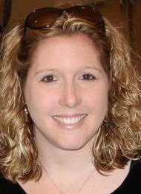
Mrs. Kelly (Hudson) Busovsky is a 1995 graduate of Newark High School and a 1999 Graduate of Shenandoah Conservatory of Music where she received her BME (Bachelor’s of Music Education) with an emphasis in voice. In 2011 Mrs. Busovsky received her Master’s Degree in Applied Technology in Education from Wilmington University. This year will be her 19th year teaching Elementary Music, Beginning, Middle School and High School Choirs at Caravel Academy. Mrs. Busovsky is an active member of DMEA (Delaware Music Educators Association), NAfME (National Association for Music Educators) and the ACDA (American Choral Director’s Association). Mrs. Busovsky is also the Chair for Children’s Choirs for the State of Delaware and runs the Delaware Children’s Honor Choir. As the State Chair, she has presented and spoken about children’s choral music at ACDA conferences

TEACHING PHILOSOPHY:
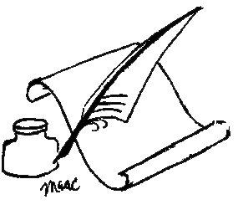
Music Education is an integral part of a child’s development. It is no secret that students who participate in music programs score higher on standardized tests and are more confident and well rounded. The music room offers a safe and enthusiastic environment to foster creativity, confidence, personal expression and FUN! Learning vocabulary, notes, rhythms and history are important but above all, developing a life-long love of the arts is the most important goal.

LITTLE BUCS CHORUS:

In 3rd & 4th grade students have the opportunity to join the Little Bucs Chorus. This ensemble meets on Tuesdays during H period (2:20pm-3:55pm) from mid-September through May. As a part of this ensemble, student will learn all about their singing voices! The Little Bucs Choir is also a great opportunity for students to learn more about music that is not covered in the regular music classroom curriculum (ex. choral literature, choral score reading, performance skills, and vocal production). This is open to all kids who have a desire to participate and develop in singing.

METHOD OF COMMUNICATION: Please feel free to email me at any time. kbusovsky@caravel.org. Please check out our Music Department website to learn about all the wonderful programs we have to offer at Caravel and to see what is happening in music class! www.camusicboosters.com Please also feel free to join our Music Boosters Association, which helps to raise funds for all of our music classes from preschool through high school. Learn more by joining the Caravel Academy Music Boosters on Facebook!

