CARAVEL ACADEMY
FIRST GRADE MUSIC

CLASS CONTENT:
Welcome to First Grade Music! This year we will be reinforcing many concepts that were introduced in our Kindergarten program including steady beat, loud/ soft (dynamics), high/low (pitch), fast/slow (tempo), basic rhythms (quarter note, quarter rest, paired eighth note), the musical alphabet, and basic music history. We will also continue to develop our singing voices. In addition to these concepts we will be learning additional rhythms (half note, half rest, dotted half note, whole note and whole rest) and we will be reinforcing our knowledge of the musical alphabet by playing pitched percussion instruments. Students will learn musical concepts through songs, musical games, Smartboard lessons and assessments included in our Quaver Music Curriculum. (A letter regarding the quaver program will be sent home soon so you can learn how to continue the musical magic at home!)
To see our weekly music curriculum, please feel free to view at:
https://www.quavermusic.com/InfoCenter/FamilyOfPrograms/CurriculumMap_pdfs/1_CurrMap.pdf

GRADING POLICY:
Students are given a final marking period grade of X, P or N. Grades are made up of 75% class participation and 25% classroom assessments. Students are given weekly class participation grades using a 4-point rubric. Students are expected to:

*Cooperate with others to accomplish lesson goals
*Respectful to people and school property (instruments, games, etc)
*Follow class rules
*Listen to and follow directions and ask for help when needed
*Be focused and engaged in the class activity
*Ba a consistent, independent and a self-motivated learner.

Students are also given class projects and class assessments to evaluate their comprehension of the subject matter. Projects and assessments not completed in the allotted time frame may need to be completed and returned outside of class. Each project is graded using a 4-point rubric. Although the class assessments are important to me as an educator, ultimately class participation is the most important. All I ask is that a child tries to do their best.

Fine Arts Festivals (Our BIG Concerts!):
Each December and May the students perform in our Fine Arts Festival. These Festivals are very important because they are much like a final project determining a level of understanding and comprehension of musical and performance standards. Students do receive a participation grade for our concerts during the second and fourth marking period. These performances provide families an opportunity to enjoy the children showcasing their enthusiasm, creativity and love of music. And let’s just face it – they are just so darn cute!!

Our Winter Festival is: Tuesday, December 11, 2018 @ 6:30pm
Our Spring Festival is: Tuesday, May 14, 2019 @ 6:30pm

ABOUT THE TEACHER:
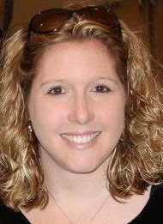
Mrs. Kelly (Hudson) Busovsky is a 1995 graduate of Newark High School and a 1999 Graduate of Shenandoah Conservatory of Music where she received her BME (Bachelor’s of Music Education) with an emphasis in voice. In 2011 Mrs. Busovsky received her Master’s Degree in Applied Technology in Education from Wilmington University. This year will be her 19th year teaching Elementary Music, Beginning, Middle School and High School Choirs at Caravel Academy. Mrs. Busovsky is an active member of DMEA (Delaware Music Educators Association), NAfME (National Association for Music Educators) and the ACDA (American Choral Director’s Association). Mrs. Busovsky is also the Chair for Children’s Choirs for the State of Delaware and runs the Delaware Children’s Honor Choir. As the State Chair, she has presented and spoken about children’s choral music at ACDA conferences.

TEACHING PHILOSOPHY:
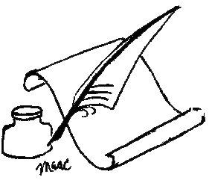
Music Education is an integral part of a child’s development. It is no secret that students who participate in music programs score higher on standardized tests and are more confident and well rounded. The music room offers a safe and enthusiastic environment to foster creativity, confidence, personal expression and FUN! Learning vocabulary, notes, rhythms and history are important but above all, developing a life-long love of the arts is the most important goal.

METHOD OF COMMUNICATION: Please feel free to email me at any time. kbusovsky@caravel.org. Please check out our Music Department website to learn about all the wonderful programs we have to offer at Caravel and to see what is happening in music class! www.camusicboosters.com Please also feel free to join our Music Boosters Association, which helps to raise funds for all of our music classes from preschool through high school. Learn more by joining the Caravel Academy Music Boosters on Facebook!

