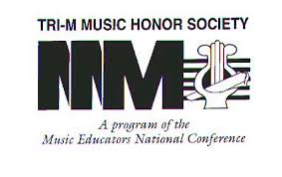

Junior Tri-M Rules and Regulations
- Members must participate in either band or chorus, and maintain a GPA of an A in their music classes and a B or higher overall to meet the standards of the society.

- Members must complete a minimum of five service hours each semester and must also volunteer at a minimum of two Caravel music events/fundraisers each semester, regardless of whether they have completed their service hour requirements during the summer.

- Students must submit their signed service completion form to the completed bin located outside the band room within one week of the event date.

- All completed service forms must be submitted prior to the semester deadline set in place at the beginning of the school year.

- All members are required to attend Caroling for Cans and the Tri-M Induction Ceremony.

- All members are required to attend all meetings. Attendance will be taken by the Secretary. Students will be allowed two excused and one unexcused absence. Students who have a conflict on the day of a meeting must email their Chapter Advisor prior to the meeting.

- Elections will be held every September at a special election meeting.

- Officers may be nominated by members, with the final decision being determined the Chapter Advisor and Co-Advisor.

- In the event of an officer not performing his/her duty, a re-election for that position may be held.

- Meetings will exclusively be run by the officers and supervised by the Chapter Advisor.

- There will be a minimum of one student-run fundraiser each semester.

- Members who do not adhere to the rules and regulations, risk having a conditional status (probation). This conditional status will expire if a student improves their standing the following semester. Students who fail to do this will be dismissed from the organization.

- Students signed up for an event, may cancel a minimum of 48 hours prior to the event unless in the case of an emergency. More than two unexcused cancellations will put a member at risk of probation.

